Guided Capstone Project Report – Step 6

Problem: What we are looking to do is find a way to implement a more data driven pricing policy for Big Mountain Resort. This translates to finding a better value for the resort’s ticket price. Here we use the resort data for the entire market to assess Big Mountains’ facilities and how they compare to the rest of the market in Montana as well as the United States. Based on these findings, we can assess operational changes in some of Big Mountain’s facilities to increase net profit for the season.

Findings:

* We identify a strategy that would increase the ticket price of Big Mountain Resort by $1.99 resulting in a **net profit for the season of $1,934,638.**
* Closing one run has no impact on revenue so closing the least popular run should save maintenance and operational costs which would be used elsewhere.

Strategy:

One factor that is driving the problem is that Big Mountain Resort is pricing itself at a premium in its market (Montana). In the data wrangling process, we see how the state of Montana’s pricing compares to the rest of the United States:

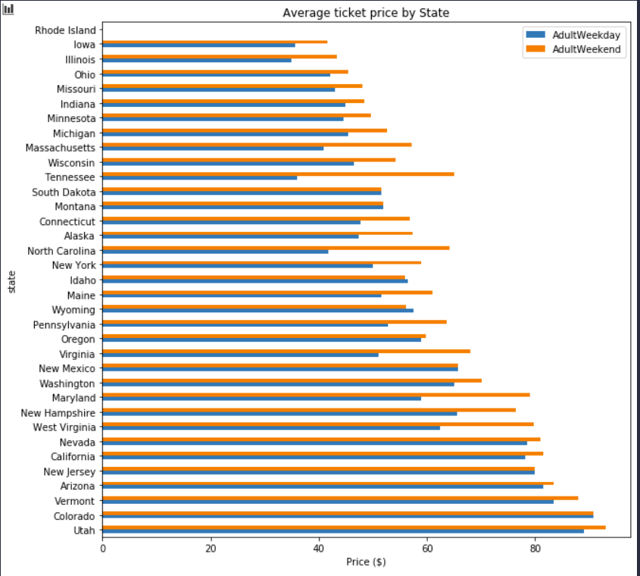

We can see that while Big Mountain Resort may be a premium in the state of Montana. This market is very average in terms of pricing when it comes to the entire US.

The question becomes, do the facilities Big Mountain has justify the need to increase the price to a premium when compared to the US market?

We next needed to do two things: identify which facilities contribute most to higher pricing and see how Big Mountain Resort compared to the market with respect to the specific facilities.

The main takeaway from the EDA process was generating a heatmap that showed which facilities correlated most with pricing. The most relevant features that we saw from the heatmap were fast quads, total chairs, runs, night skiing, and snow making. We use this information in the preprocessing and modeling steps to evaluate Big Mountain Resort.

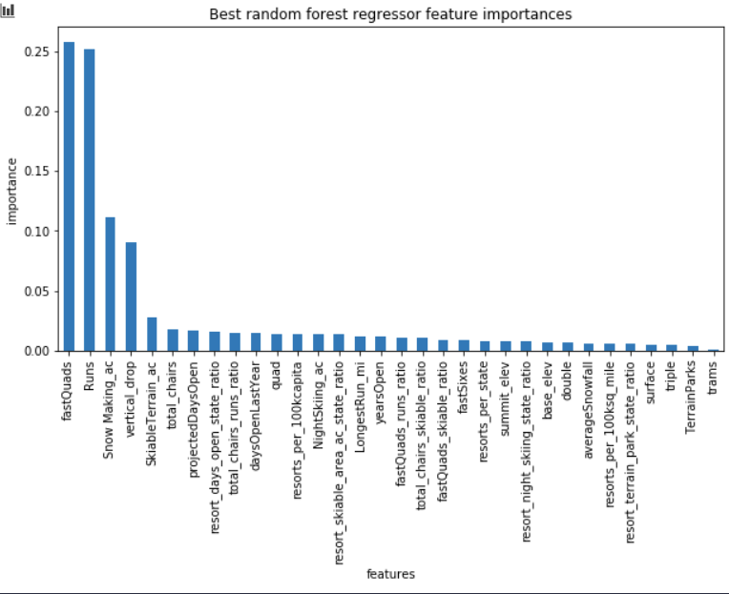

Through a random forest model we were able to validate which of these features were most important on a quantitative scale. After optimizing parameters we were able to plot this graph ranking the most important features. The top 6 were fast quads, runs, snow making ac, vertical drop, skiable terrain, and total chairs.

Before implementing these final experiments, we took a look at how much Big Mountain Resort was charging, which is $81. From pre-processing we saw how Big Mountain Resort compares to other resorts overall as well as other resorts in Montana when it comes to the most relevant features we identified (fast quads, runs, snow making ac, vertical drop, skiable terrain, and total chairs). The features among this list that Big Mountain has more of than most of the market are ones we identified in our modeling scenarios.

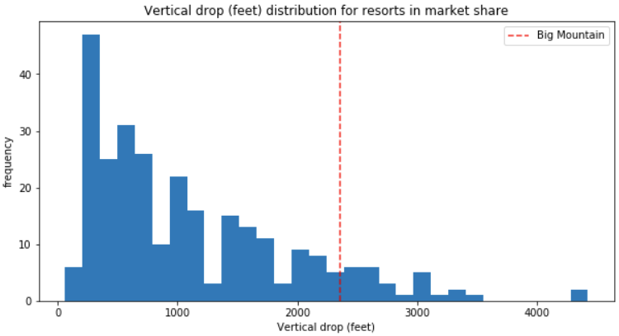 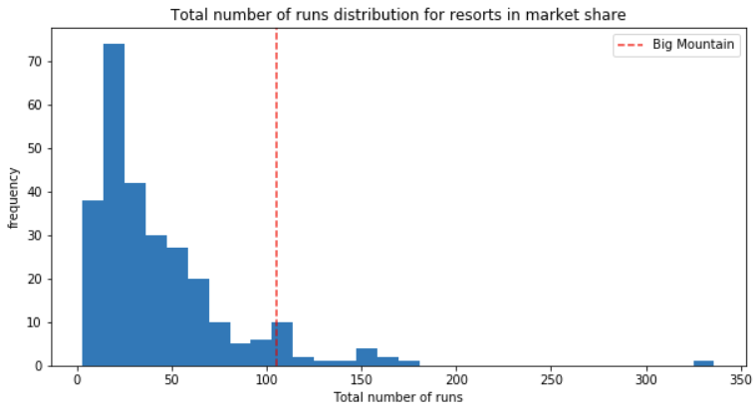 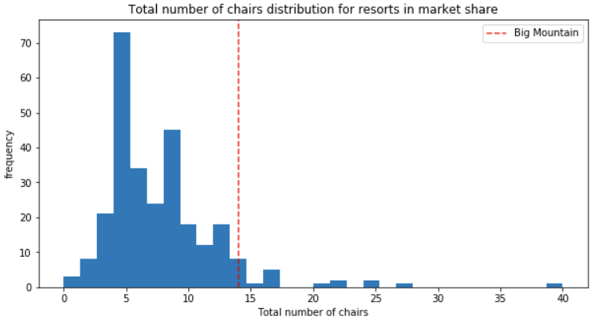

These facilities (vertical drop, number of runs, and number of chairs) which were ranked as some of the most important according to our random forest model, reveal Big Mountain’s place ahead of most of the U.S. market.

These three facilities are the ones we vary in our pricing model to increase ticket price.

We finally ran a predictive model where based on the expected number of visitors of 350,000, we predict revenue loss based on the number of runs closed and we predict the increase in ticket price by adding a run, increasing the vertical drop by 150 feet, and installing an additional chair lift.

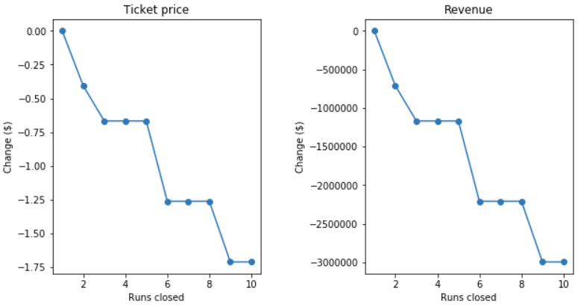

With the run closures, we see that closing one run has no affect on revenue loss. Closing the least popular run would allow Big Mountain to save on those maintenance and operational costs while maintaining the same revenue.

The suggestion to business leadership would be to consider this model. The operational cost of a new chair lift would be $1,540,000 for the season. The model supports an increase in ticket price by $1.99, which on the basis of each visitor on average buying 5 day tickets would produce $3,474,638 for the season. Net profit in this case would turn out to be $1,934,638.